Summer Reading Log Assignment

Follow the instructions below based off of which book you chose for summer reading.
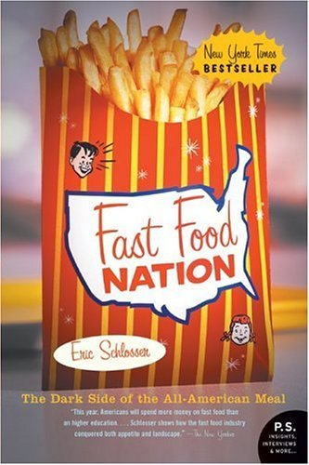
Fast Food Nation:
Keep a log of EVERYTHING you eat and drink between now and MONDAY, AUGUST 24. Make sure to record where you get the food (name of restaurant, school cafeteria, mom/dad cooked it, pre-packaged snack, etc.) Highlight any meals/snacks that you did not know all of the ingredients; read labels and record any ingredients you have never heard of.
This is for your eyes only, so be honest!

Nickel and Dimed:
Keep a log of EVERYTHING you buy and your parents buy you between now and MONDAY, AUGUST 24. Make sure to record where it comes from and how much it cost, when possible. Also, record any money you receive, whether it be allowance from parents or pay from a job. At some point in the log, maybe at the end, ask your parents to estimate how much they spend on you monthly (food, clothes, housing, car, etc.) and the breakdown of where that money goes.
This is for your eyes only, so be honest!

For either book, your log is due MONDAY, AUGUST 24. This log spans over 11 days, so you should have 11 entries total. The more effort you put into your log, the easier your work on Monday, August 24 will be!

Example Food Log with Fast Food Nation:
Date | What you ate | Where it came from | Not sure what all the ingredients are? Any weird ingredients?
8/12 | Breakfast burrito | Taco Bell | Not sure all ingredients
8/12 | Cool Ranch Doritos | Packaged snack | Monosodium glutamate  Disodium inosinate  Disodium guanylate

Example Money Logs with Nickel and Dimed:
Date | What you bought | Where? | Estimated Cost?
8/12 | Snacks at vending machine | School | $2
8/12 | Chicken taco dinner | Applebees | $15

Date | Amount Earned/given to me | Why/from where?
8/14 | $45 | Job at publix
8/14 | $10 | parents

